Hello,

On behalf of everyone at EPTECH, we’re truly looking forward to welcoming you in-person to our 2023 event at Best Western Premier Calgary Plaza Hotel and Conference Centre in September. Here’s some general information to help you with your planning:

LOCATION & DATE

Exhibitor setup – September 26, 2023, at 8 AM
Trade Show – September 26, 2023, at 10 AM
Best Western Premier Calgary Plaza Hotel and Conference Centre
1316 33 St NE, Calgary, AB T2A 6B6

AIRPORT OPTIONS
You can fly into YYC with easy access to the hotel.
Calgary International Airport
Distance to hotel 12.7km. Estimated taxi fare: $30 CAD (one way)
Visit YYC airport website

ACCOMMODATIONS
Reservations can be made online by direct booking or by calling (403)-248-8888

EPTECH 2023 is a 1-day event (September 26, 2023), however, we have successfully secured a special room rate of $125 per night for delegates staying between Wednesday, September 25th – Friday, September 27th, 2023.

You can reserve by:
- Calling the Reservations Dept: 403-248-8888 or 1-800-661-1464
-Emailing at res@calgarplaza.com
-Quoting either: EPTECH Show
Or
Block ID: 223205

Reservations must be received on or before 5:00PM, Thursday, August 1^{sh}. After 5:00pm, the Hotel will release the unreserved rooms for general sale and determine whether it can accept reservations based on a space.

PARKING

FREE parking will be available. Attendees can access the parking lot through 33 St NE.
License plates must be registered at the Front Desk.

SHIPPING / RECEIVING
For shipping, please use the address below and note Calgary Show.

ATN: Jessica Davey
EPTECH SHOW – Plaza 1&2
BWP Calgary Plaza
1316 33 ST NE
CALGARY, AB
T2A 6B6

The hotel does not have storage space for crates, pallets, or large shipments. Any materials to be sent to the Hotel may arrive no earlier than 5 days prior to April 20, 2023.

If you require advanced warehousing for other EPTECH shows, please contact Kevin at Boneyard Event Services kevin@bes.show or by calling 416-938-1063.

POWER at your BOOTH
If power is required or if you aren’t sure, you have booked power, please contact Maria Parada at mparada@annexbusinessmedia.com

WIFI
Wi-Fi is available in guest rooms, public space, and the meeting space-for general browsing. If you were showing a product demo online at your booth, for example, you might want to purchase a better connection.

BOOTH SPECIFICATIONS
Your space includes one 8’ skirted table (8’ = 1.82m) with 2 chairs.
Plaza 1-2 is a fully carpeted space (photo below).

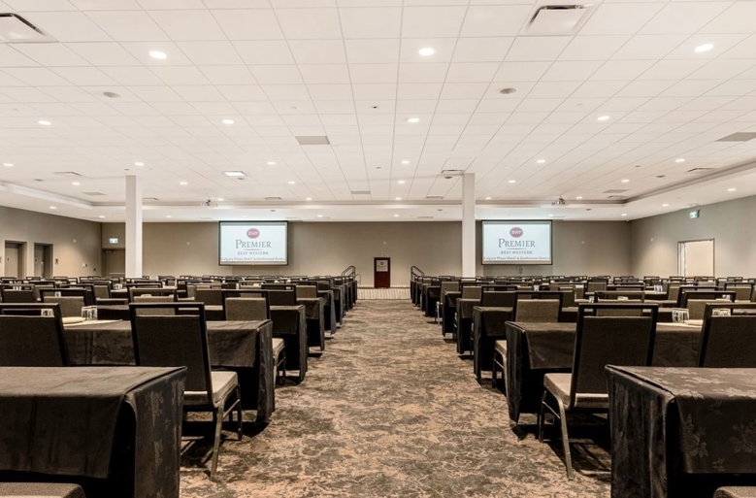

STAFFING
Sponsor and exhibitor packages includes 2 complimentary staff pass. This pass includes a light breakfast and lunch.

NAME BADGE
Please fill out the spreadsheet attached and email back to mparada@annexbusinessmedia.com for attending staff (as you would like it to appear on the name badge).

INSURANCE
Exhibitor insurance is mandatory. A certificate of insurance can be requested either through your existing insurance provider or can be purchased via link below. Insurance Certificates can be submitted to mparada@annexbusinessmedia.com.

Exhibitor Insurance Application

If there’s anything else I can help with, please don’t hesitate to reach out!

Maria Parada

