Hello,

On behalf of everyone at EPTECH, we’re truly looking forward to welcoming you in-person to our 2023 event at Delta Hotels by Marriott Burnaby Conference Centre in June. Here’s some general information to help you with your planning:

LOCATION & DATE

Exhibitor setup – June 7, 2023 at 8 AM
Trade Show – June 7, 2023 at 10 AM
Delta Hotels by Marriott Burnaby Conference Centre
4331 Dominion St, Burnaby, BC V5G 1C7

AIRPORT OPTIONS
You can fly into YVR with easy access to the hotel.

Vancouver International Airport (YVR)
Distance to hotel 18.7km. Estimated taxi fare: $54 CAD (one way)
Visit YVR airport website

ACCOMMODATIONS
Reservations can be made online by direct booking or by calling (604) 453-0750

EPTECH 2023 is a 1 day event (June 7, 2023), however, we have successfully secured a special room rate of $269 per night for delegates staying between Tuesday, June 6 – Thursday, June 8, 2022.

Book your group rate for EPTECH Vancouver Show
Reservations must be received on or before 5:00PM, Wednesday, May 9th. After 5:00pm, the Hotel will release the unreserved rooms for general sale and determine whether it can accept reservations based on a space.

PARKING

FREE parking will be available. Attendees can access the parking lot through Dominion St.
No special requirements for parking are needed.

SHIPPING / RECEIVING
For shipping, please use the address below and note Vancouver Show.

Attn: EPTECH 2023 (your company name), Tianhu Fan, June 7, 2023, ballroom.
4331 Dominion Street
Burnaby, BC V5G 1C7
(Box 1 of 3)

The hotel does not have storage space for crates, pallets, or large shipments. Any materials to be sent to the Hotel may arrive no earlier than 1 day prior to June 7, 2023. A handling and storage fee (plus all applicable dates) will be assessed and charged accordingly.

Delta Hotels Handling Fees
Services Include: Handling of packages at loading bay during business hours (Monday through Friday
8:00 am to 4:30 pm) and delivery to your function room.
- Boxes (under 30 lbs each) – $5 plus tax per box
- 75 plus taxes per palette each way ($150 round trip)
- Shipping assistance (boxing, labelling, packing) - $35/hour labour (includes tape and plastic wrap)

Delta Hotels Policies
Packages must be received through the loading dock and transported through the freight
elevators. Items received must not exceed 7’ tall by 5’ wide by 5’deep.
- Hotel will not receive packages through the front desk.
- Hotel will not receive or sign Cash-On-Delivery packages (C.O.D shipments) or be responsible for international duties. We recommend using a customs broker for international shipments.
- Outbound shipments require online waybills provided by the shipper, once packaged the Event
- Services Attendants will collect your package, and store with receiving for shipping the following business day. Please ensure the provider and waybills are clearly marked on the packages.
- Any packages left for more than 48 hours after an event, will be subject to freight storage fees by a third-party vendor as your packages will no longer be stored on property.

If you require advanced warehousing for other EPTECH shows, please contact Kevin at Boneyard Event Services kevin@bes.show or by calling 416-938-1063.

POWER at your BOOTH
If power is required or if you aren’t sure, you have booked power, please contact Maria Parada at mparada@annexbusinessmedia.com

WIFI
Wi-Fi is available in guest rooms, public space, and the meeting space-for general browsing. If you were showing a product demo online at your booth, for example, you might want to purchase a better connection.

BOOTH SPECIFICATIONS
Your space includes one 8’ skirted table (8’ = 1.82m) with 2 chairs.
The ballroom, is a fully carpeted space (photo below).

CLICK HERE FOR A 360 TOUR

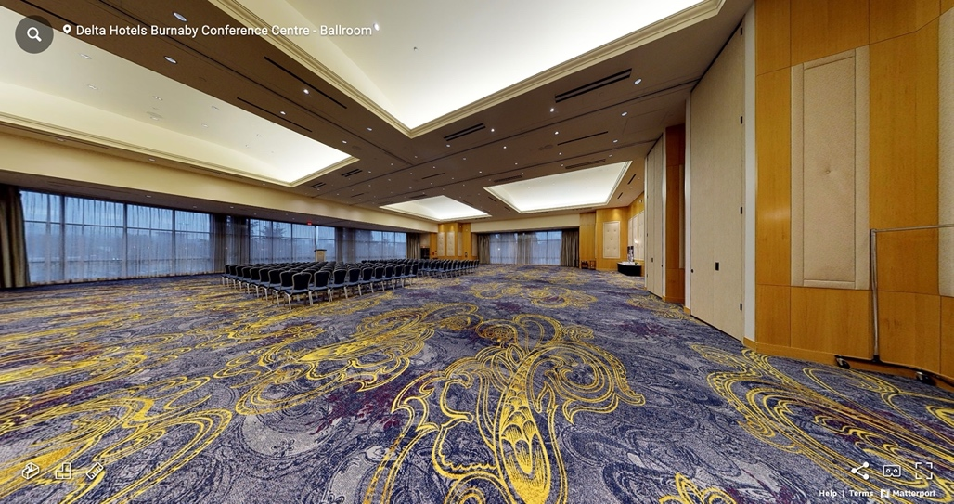

STAFFING
Sponsor and exhibitor packages includes 2 complimentary staff pass. This pass includes a light breakfast and lunch.

NAME BADGE
Please fill out the spreadsheet attached and email back to mparada@annexbusinessmedia.com for attending staff (as you would like it to appear on the name badge).

INSURANCE
Exhibitor insurance is mandatory. A certificate of insurance can be requested either through your existing insurance provider or can be purchased via link below. Insurance Certificates can be submitted to mparada@annexbusinessmedia.com.

Exhibitor Insurance Application

If there’s anything else I can help with, please don’t hesitate to reach out!

Maria Parada

