Hello,

On behalf of everyone at EPTECH, we’re truly looking forward to welcoming you in-person to our 2023 event at Victoria Inn Hotel & Convention Centre in April. Here’s some general information to help you with your planning:

LOCATION & DATE

Exhibitor setup – April 20, 2023, at 8 AM
Trade Show – April 20, 2023, at 10 AM
Victoria Inn Hotel & Convention Centre
1808 Wellington Ave, Winnipeg, MB R3H 0G3

AIRPORT OPTIONS
You can fly into YWC with easy access to the hotel.
Winnipeg James A Richardson International Airport
Distance to hotel 2.5km. Estimated taxi fare: $15 CAD (one way)
Visit YWC airport website

ACCOMMODATIONS
Reservations can be made online by direct booking or by calling (204) 786 4801

EPTECH 2023 is a 1-day event (April 20, 2023), however, we have successfully secured a special room rate of $144 per night for delegates staying between Wednesday, April 19th – Saturday, April 22nd, 2023.

To reserve please call 204-786-4801 and ask to reserve a room in the Annex group block (group code 267679) to access the discounted rate

Reservations must be received on or before 5:00PM, Monday, March 20th. After 5:00pm, the Hotel will release the unreserved rooms for general sale and determine whether it can accept reservations based on a space.

PARKING

FREE parking will be available. Attendees can access the parking lot through Berry St.
No special requirements for parking are needed.

SHIPPING / RECEIVING
For shipping, please use the address below and note Winnipeg Show.

Attn: EPTECH 2023 (your company name), Sherjil Abbas, April 20, 2023, Centennial North room
1808 Wellington Ave.
Winnipeg, MB
R3H 0G3

The hotel does not have storage space for crates, pallets, or large shipments. Any materials to be sent to the Hotel may arrive no earlier than 1 day prior to April 20, 2023. A handling and storage fee of $5 per box/item or $2 per pound (plus all applicable dates) will be assessed and charged accordingly.

If you require advanced warehousing for other EPTECH shows, please contact Kevin at Boneyard Event Services kevin@bes.show or by calling 416-938-1063.

POWER at your BOOTH
If power is required or if you aren’t sure, you have booked power, please contact Maria Parada at mparada@annexbusinessmedia.com

WIFI
Wi-Fi is available in guest rooms, public space, and the meeting space-for general browsing. If you were showing a product demo online at your booth, for example, you might want to purchase a better connection.

BOOTH SPECIFICATIONS
Your space includes one 8’ skirted table (8’ = 1.82m) with 2 chairs.
The Centennial North room, is a fully carpeted space (photo below).

CLICK HERE FOR A VIRTUAL TOUR

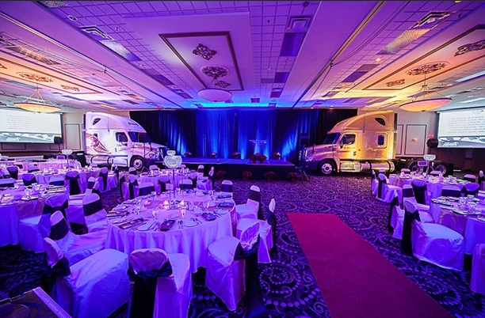

STAFFING
Sponsor and exhibitor packages includes 2 complimentary staff pass. This pass includes a light breakfast and lunch.

NAME BADGE
Please fill out the spreadsheet attached and email back to mparada@annexbusinessmedia.com for attending staff (as you would like it to appear on the name badge).

INSURANCE
Exhibitor insurance is mandatory. A certificate of insurance can be requested either through your existing insurance provider or can be purchased via link below. Insurance Certificates can be submitted to mparada@annexbusinessmedia.com.

Exhibitor Insurance Application

If there’s anything else I can help with, please don’t hesitate to reach out!

Maria Parada

