Hello,

On behalf of everyone at EPTECH, we’re truly looking forward to welcoming you in-person to our 2023 event at DoubleTree by Hilton Pointe Claire Montreal Airport West in September. Here’s some general information to help you with your planning:

LOCATION & DATE

Exhibitor setup – September 6, 2023 at 8 AM
Trade Show – September 6, 2023 at 10 AM
DoubleTree by Hilton Pointe Claire Montreal Airport West
6700 Trans-Canada Hwy, Pointe-Claire, Quebec H9R 1C2

AIRPORT OPTIONS
You can fly into YUL with easy access to the hotel.

Montreal-Trudeau International Airport (YUL)
Distance to hotel 14.8km. Estimated taxi fare: $29 CAD (one way)
Visit YUL airport website

ACCOMMODATIONS
Reservations can be made online by direct booking or by calling 514-697-7110 Group code: CDTCE2
EPTECH 2023 is a 1-day event (September 6, 2023), however, we have successfully secured a special room rate of $179 per night for delegates staying between Tuesday, September 5 – Thursday, September 7, 2022.

Book your group rate for EPTECH Montreal Show
Reservations must be received on or before 5:00PM, Wednesday, August 9th. After 5:00pm, the Hotel will release the unreserved rooms for general sale and determine whether it can accept reservations based on a space.

PARKING

FREE parking will be available. Attendees can access the parking lot through Holiday Ave.
No special requirements for parking are needed.

SHIPPING / RECEIVING
For shipping, please use the address below and note Montreal Show.

Attn: EPTECH 2023 (your company name), Diane Cadieux
c/o DoubleTree par Hilton Pointe-Claire,
6700 route Transcanadienne,
Pointe-Claire, Qc, H9R 1C2
September 6, 2023
Room: Champagne

The hotel does not have storage space for crates, pallets, or large shipments. Any materials to be sent to the Hotel may arrive no earlier than 2 days prior to September 6, 2023. In the event a package arrives earlier or shipped later than 2 working days of the event, a handling & storage fee of 15.00$ per day, per box will apply. Please note that the DoubleTree par Hilton Pointe-Claire does not have a raised loading dock.

If you require advanced warehousing for EPTECH shows, please contact Kevin at Boneyard Event Services kevin@bes.show or by calling 416-938-1063.

POWER at your BOOTH
If power is required or if you aren’t sure, you have booked power, please contact Maria Parada at mparada@annexbusinessmedia.com

WIFI
Wi-Fi is available in guest rooms, public space, and the meeting space-for general browsing. If you were showing a product demo online at your booth, for example, you might want to purchase a better connection.

BOOTH SPECIFICATIONS
Your space includes one 8’ skirted table (8’ = 1.82m) with 2 chairs.
The Champagne is a fully carpeted space (photo below).

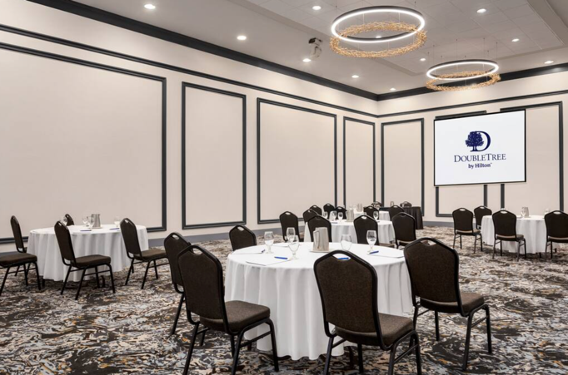

STAFFING
Sponsor and exhibitor packages includes 2 complimentary staff pass. This pass includes a light breakfast and lunch.

NAME BADGE
Please fill out the spreadsheet attached and email back to mparada@annexbusinessmedia.com for attending staff (as you would like it to appear on the name badge).

INSURANCE
Exhibitor insurance is mandatory. A certificate of insurance can be requested either through your existing insurance provider or can be purchased via link below. Insurance Certificates can be submitted to mparada@annexbusinessmedia.com.

Exhibitor Insurance Application

If there’s anything else I can help with, please don’t hesitate to reach out!

Maria Parada

